23CSE202 DATABASE MANAGEMENT SYSTEMS
S3 B.Tech CSE
Department of Computer Science and Engineering
Amrita School of Computing, Amritapuri Campus

PROJECT REPORT

Group No : C3
Team Members :
Roll No | Student Name
Am.sc.u4cse25253 | Sujeeth S
Am.sc.u4cse25239 | Nithish Kumar S
Am.sc.u4cse25262 | Nithilan S
Am.sc.u4cse25259 | Yaksh Chouhan

Project Title :
E-Commerce Database Management System

CONTENTS
Sl. No | Chapter | Page No
1 | Abstract
2 | Introduction
3 | Requirements (Functional & Non-functional)
4 | UI Design
5 | Database Design
6 | Database Selection & Justification
7 | Implementation
8 | Testing & Validation
9 | Results & Screenshots
10 | Challenges faced & solutions
11 | Conclusion & future enhancements
 | References

What is Expected in each chapter
1. Abstract (1 paragraph)
The rapid growth of online shopping has fundamentally changed how we buy and sell, but behind every seamless checkout is a complex web of data. Traditional or ad-hoc methods for tracking inventory, customers, and orders are slow, prone to errors, and nearly impossible to scale. This project sets out to solve that problem by building a centralized, highly efficient E-Commerce Database Management System (DBMS) designed to handle the heavy lifting of an online storefront.
At its core, the system is a database-driven application built for two main types of users:
- Customers: Experience a smooth, secure shopping journey. They can create accounts, browse products by category, manage their carts, securely check out, and track their order history.
- Administrators: Get a powerful backend to keep the business running. They can update product catalogs, manage inventory levels in real-time, process orders, verify payments, and pull sales reports.
Under the hood, the system relies on a robust relational architecture. It connects core entities—such as Customers, Products, Categories, Carts, Orders, and Payments—using strict primary and foreign key relationships to guarantee data integrity. The database is fully normalized to eliminate redundancy and keep query performance fast.
Because a modern e-commerce platform requires more than just basic CRUD (Create, Read, Update, Delete) operations, this project implements advanced DBMS features. We utilize complex SQL joins, views, stored procedures, triggers, and transaction management to ensure the platform isn't just functional, but also secure and reliable under pressure.
Ultimately, this project bridges the gap between database theory and real-world software engineering. It serves as a comprehensive, hands-on application of entity-relationship modeling, database design, and SQL programming—demonstrating exactly how a well-architected database acts as the engine behind any successful online business.

2. Introduction (1-2 pages)
Managing a digital retail environment requires seamless coordination between frontend user interfaces and backend data storage. While enterprise-level solutions exist, small to medium-scale businesses often struggle with disjointed tools that lead to overselling, inaccurate pricing, and fragmented customer records. The primary technical challenge in these systems lies in maintaining strict data consistency—ensuring that when a customer places an order, the inventory reflects that change instantaneously without race conditions, security vulnerabilities, or data corruption.
CartLedger was conceptualized to address these specific vulnerabilities by providing a streamlined, single-service architecture that tightly couples a responsive web frontend with a rigorous backend relational database. Rather than relying on client-side logic, which is inherently vulnerable to manipulation, this system shifts all critical business computations—such as stock validation, price aggregation, and role-based access control—to a centralized server environment. By utilizing Python (FastAPI) and an embedded SQLite database, the project demonstrates how enforcing database constraints, transaction atomicity, and functional dependencies at the server level can effectively solve the data synchronization and security issues prevalent in modern digital retail
3. Requirements (Functional & Non-functional) (1 page)
Functional Requirements:
- User Authentication & Authorization: The system must support role-based access control (Customers and Administrators) with secure login and registration capabilities.
- Product Catalog & Searching: Customers must be able to browse products and filter them dynamically by category (e.g., Electronics, Fashion, Home & Kitchen, Books).
- Shopping Cart Management: Customers must be able to add products to a temporary session cart, update quantities, and view real-time line totals.
- Order Processing & Stock Validation: Upon checkout, the system must validate stock levels dynamically on the server, calculate the total amount, deduct purchased quantities from the inventory, and generate an order record.
- Order History & Tracking: Customers must be able to view past orders and live tracking statuses (e.g., Paid, Shipped).
- Administrative Dashboard: Administrators must have access to live metrics, including total revenue, order count, total catalog size, and low-stock alerts.
- Inventory Management: Administrators must be able to add new products, update existing pricing, and modify stock counts.
- Order Fulfillment: Administrators must be able to view all incoming customer orders and update their fulfillment statuses.
Non-functional Requirements:
- Performance: The system must leverage a single-service architecture where the API directly serves static assets and processes data, ensuring low-latency responses.
- Security: Business logic, price calculations, and stock validations must be computed entirely on the backend to prevent client-side manipulation.
- Reliability & Data Integrity: The relational database must enforce constraints (e.g., unique emails, non-negative stock) and maintain ACID properties during checkout transactions.
- Usability: The user interface must be intuitive, responsive, and provide clear feedback via toast notifications and dynamic DOM updates.
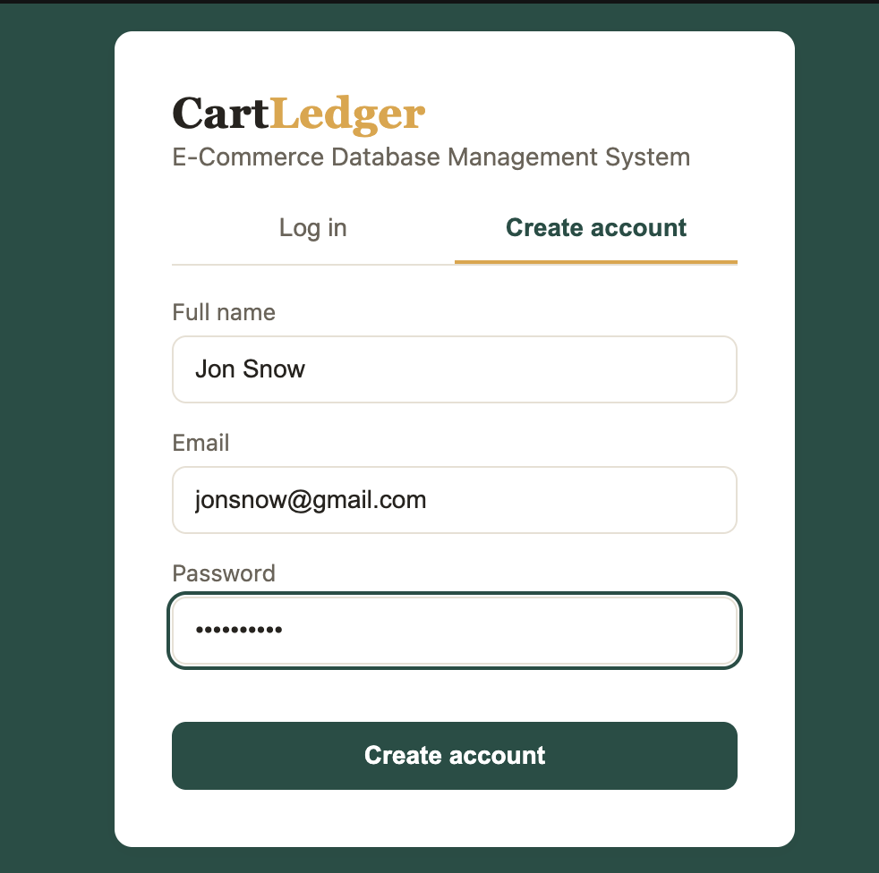
4. UI Design (2-3 pages)
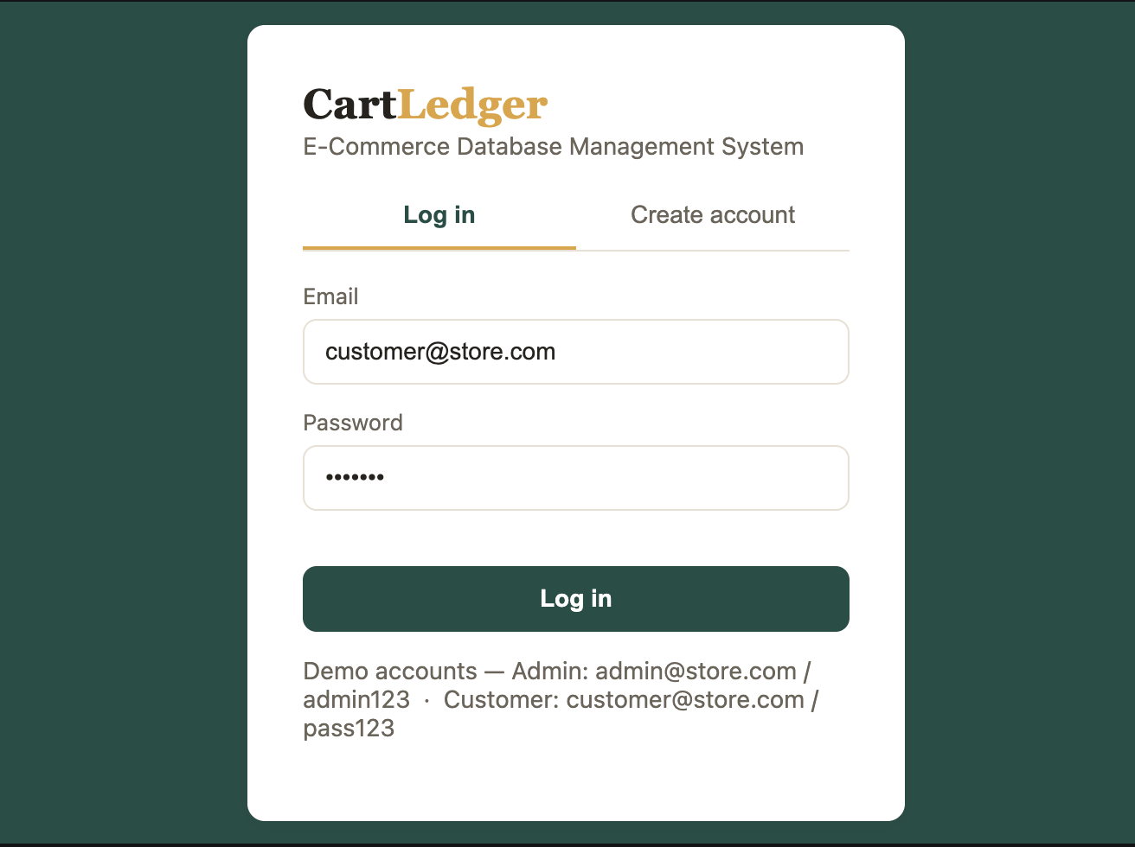


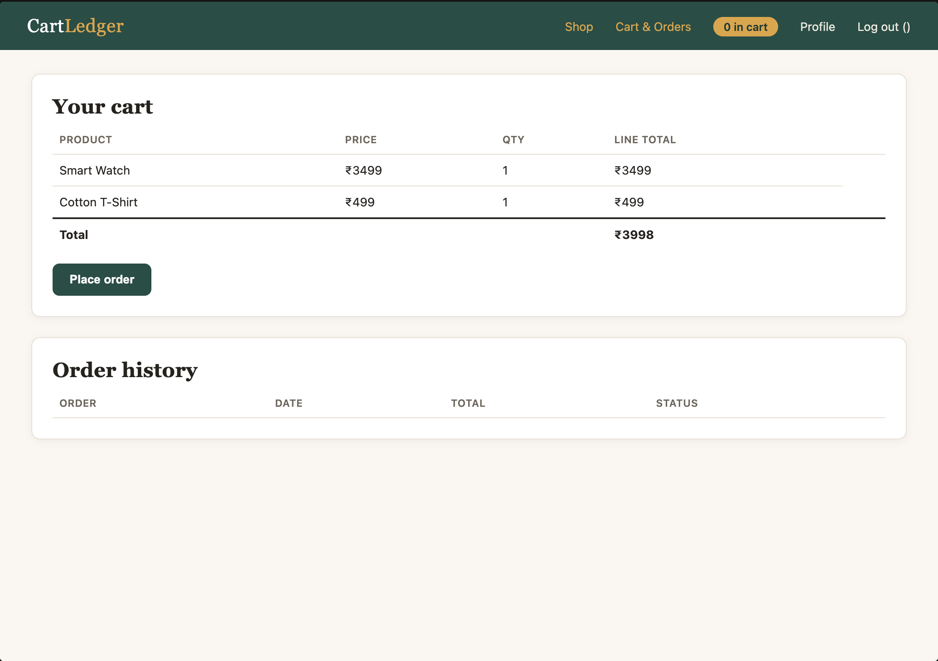



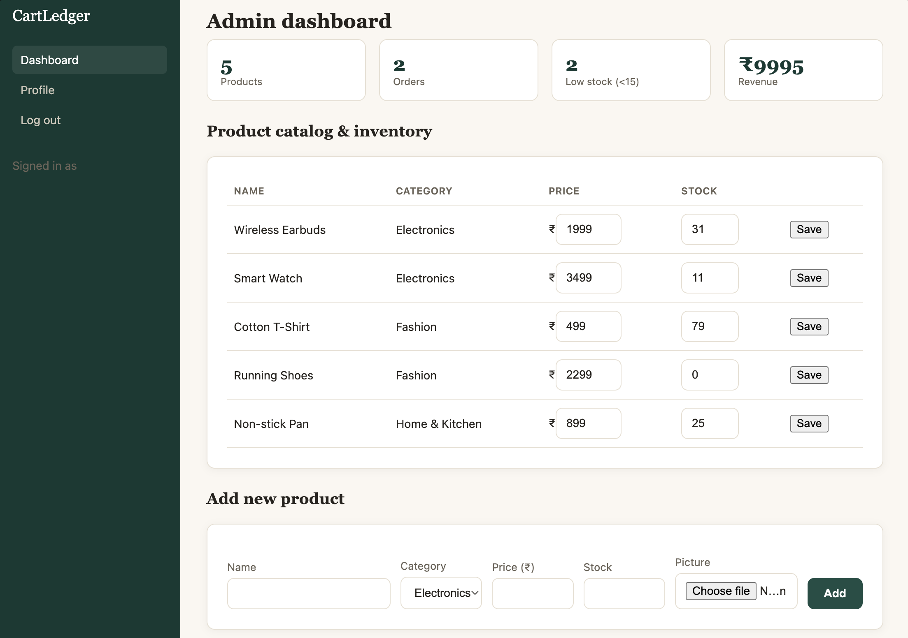
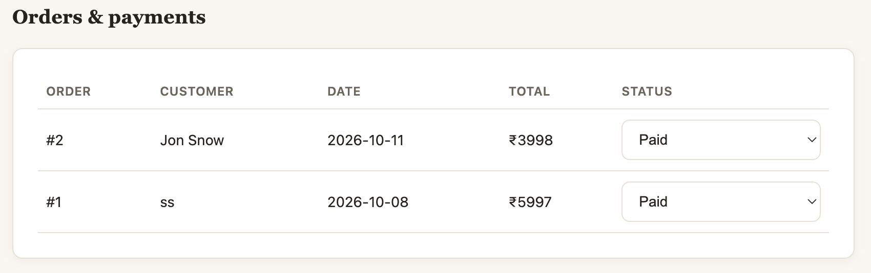

5. Database Design
Relational Schema

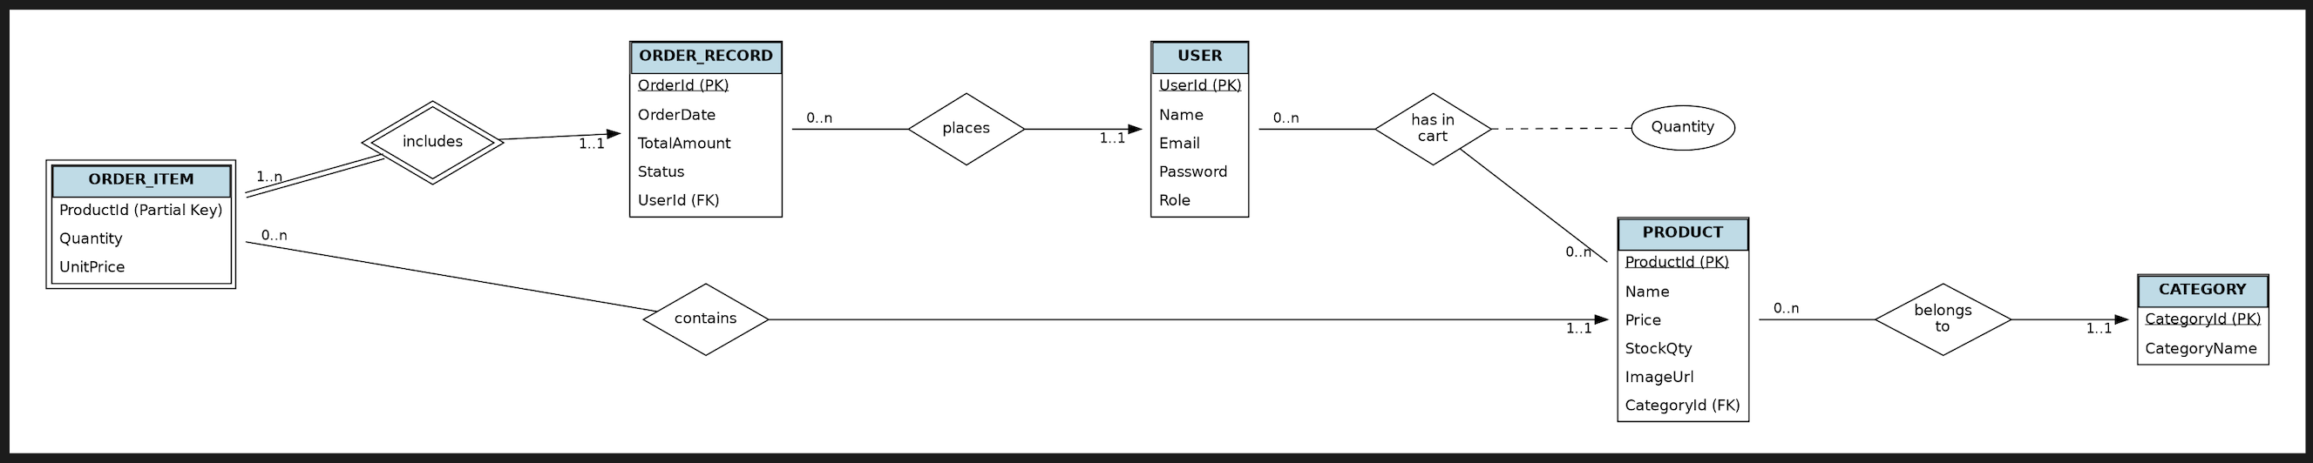
ER Diagram

The database design revolves around four primary entities: USERS, PRODUCTS, ORDERS, and the associative mapping of items.
Functional Dependencies (FDs):
- Users: {UserId} → {Name, Email, Password, Role}
- Products: {ProductId} → {Name, Category, Price, StockQty, ImageUrl}
- Orders: {OrderId} → {OrderDate, TotalAmount, Status, UserId}
- OrderItems: {OrderId, ProductId} → {Quantity, UnitPrice}
Normalization Process:
- 1NF: Multi-valued cart and order contents are separated into their own structures rather than being stored as lists inside the USER or ORDERS tables.
- 2NF: No partial dependencies exist. Attributes depend entirely on their respective primary keys.
- 3NF/BCNF: Every determinant is a candidate key, eliminating transitive dependencies. For example, a user's role does not determine order status.

6. Database Selection & Justification
SQLite was selected as the Database Management System (DBMS) for this project.
- Zero-Configuration & Serverless: SQLite is embedded directly into the FastAPI application, eliminating the need for a separate database server setup, which perfectly matches the project's lightweight, single-service architecture.
- ACID Compliance: It fully supports atomic transactions, ensuring that when an order is placed, both the order record creation and the inventory deduction succeed or fail together, preventing data corruption.
- Ease of Integration: Python's built-in sqlite3 library allows for seamless integration. The use of sqlite3.Row as the row_factory enables the API to fetch and return query results directly as JSON-serializable dictionaries.
- Portability: The entire database resides in a single cross-platform file (ecommerce.db), making it highly portable for development and testing.

7. Implementation
The backend is implemented using Python and the FastAPI framework, handling REST endpoints, data validation via Pydantic models, and static file routing.
Database Creation & Schema: The database is initialized on server startup. If the tables do not exist, they are generated using SQL DDL statements.
CREATE TABLE IF NOT EXISTS users (
id INTEGER PRIMARY KEY AUTOINCREMENT,
name TEXT NOT NULL,
email TEXT UNIQUE NOT NULL,
password TEXT NOT NULL,
role TEXT NOT NULL DEFAULT 'customer'
);
Complex Join Queries (Admin Dashboard): To generate the order fulfillment table, the system joins the orders and users tables to display the customer's actual name alongside their order details.

SELECT orders.id, users.name as customer_name, orders.date, orders.total, orders.status
FROM orders
JOIN users ON orders.user_id = users.id
ORDER BY orders.id DESC;
CRUD Operations (Stock Deduction Transaction): During checkout, the system calculates the exact total dynamically based on database prices (ignoring client-side prices for security), inserts the order, and updates product stock in a batch process.
# Server-side checkout transaction snippet
cursor.execute("INSERT INTO orders (user_id, total, status, date) VALUES (?, ?, 'Paid', ?)",
(data.userId, total_amount, order_date))
for item in data.items:
cursor.execute("UPDATE products SET stock = stock - ? WHERE id = ?",
(item.qty, item.productId))
conn.commit()

8. Testing & Validation
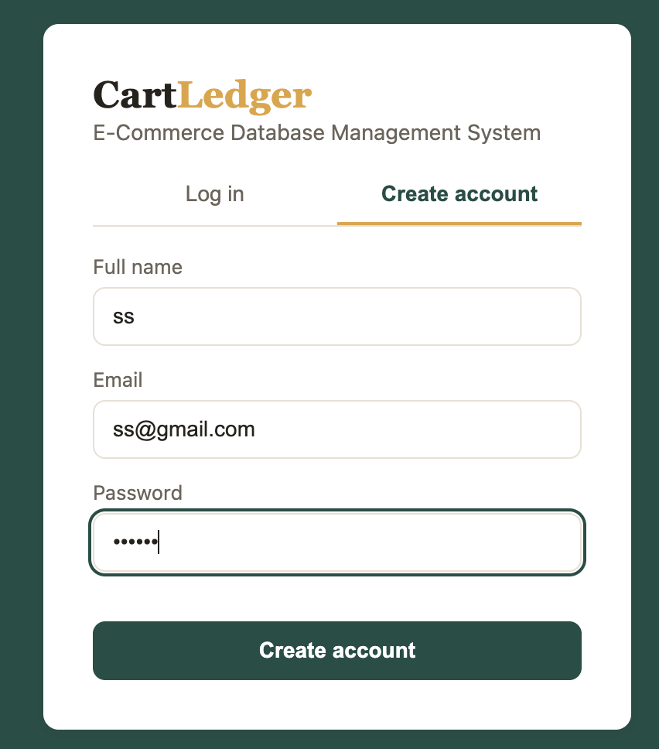

Creating account with name as “ss” and mail id as
ss@gmail.com


Logged in


Added products in the cart

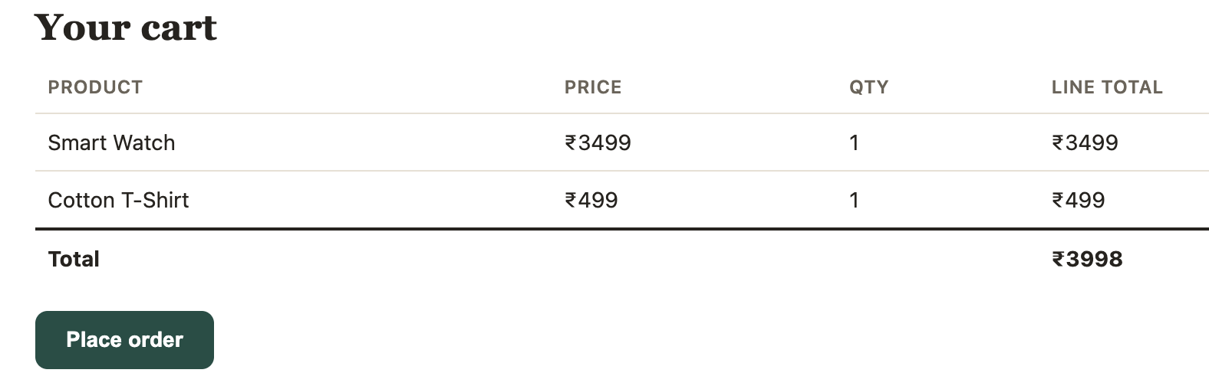

Order placed


Products and Add new product in admin dashboard
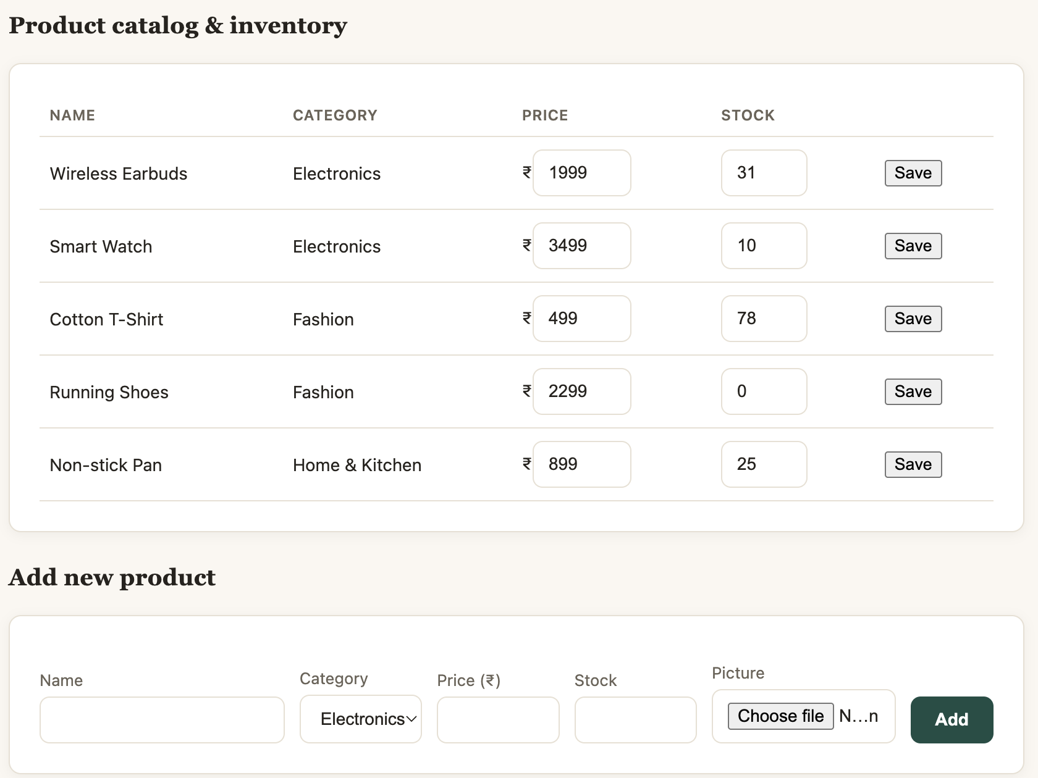


Placed orders show up in admin
dashboard and can change status


Status changed in ”ss” account

9. Results & Screenshots
Database View - cart_items table demonstrating active user sessions
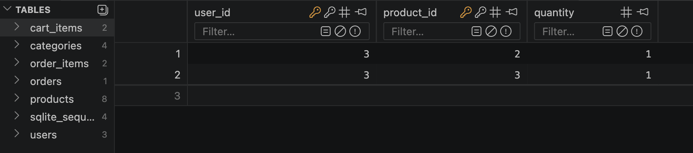

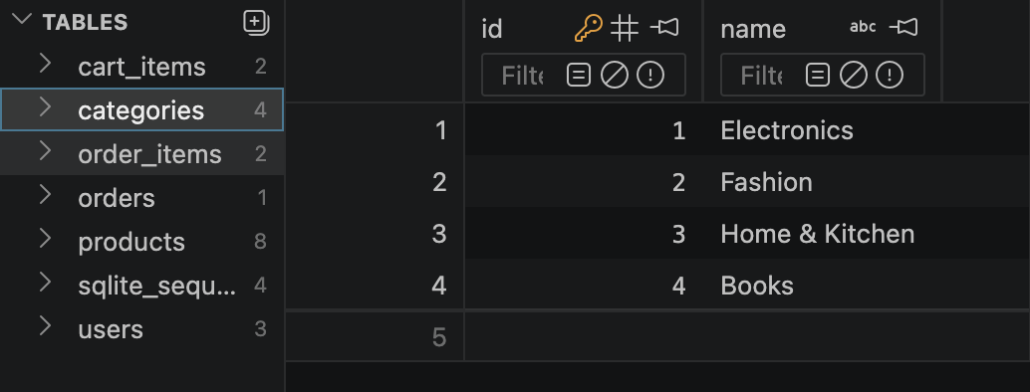
Categories table

orders
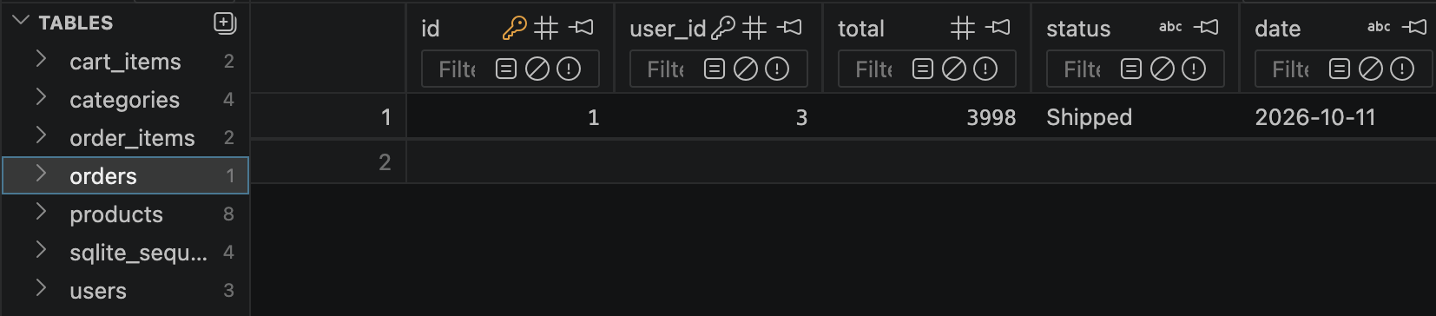
order_items
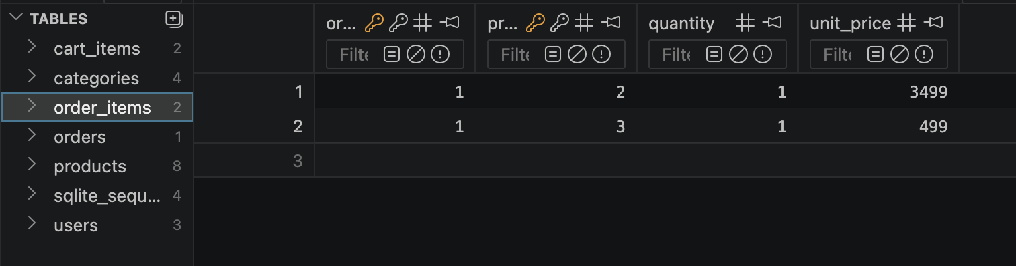

products

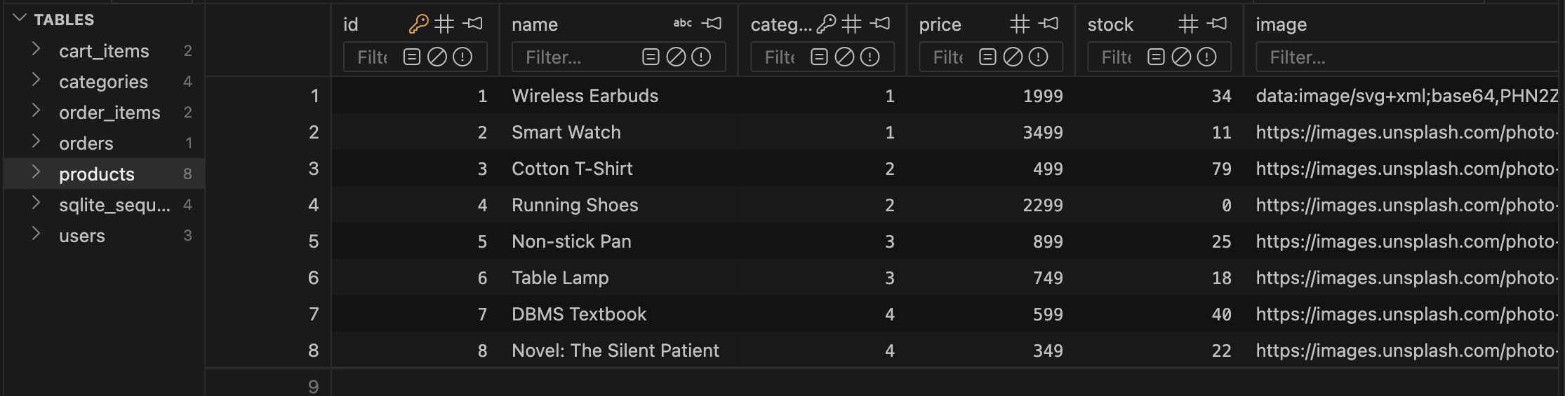

users
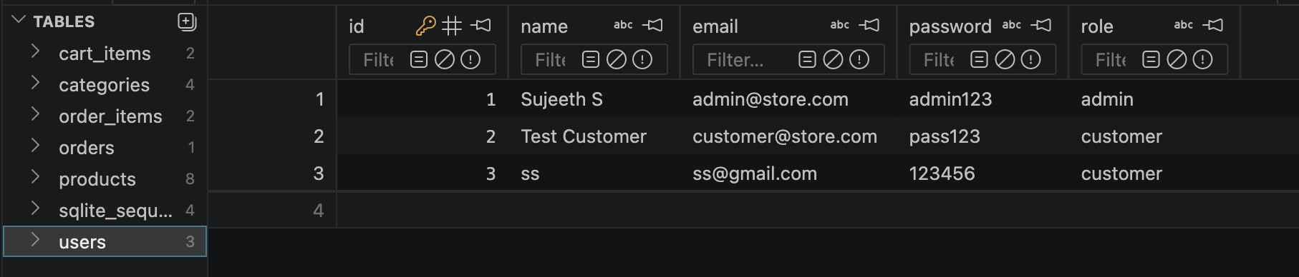

10. Challenges Faced & Solutions
- Challenge 1: Database Normalization vs. Application Complexity
- Issue: Initially, the database was partially denormalized. Categories were stored as simple text strings within the products table, and the user's shopping cart was managed entirely in the browser's local storage without backend persistence.
- Solution: The schema was completely restructured into a fully normalized 6-table design (adding categories, order_items, and cart_items). To keep the frontend smooth while respecting the new database design, a background /api/cart/sync endpoint was developed. This allowed the frontend to instantly sync local cart changes (additions, quantity updates, and deletions) to the database without requiring page reloads.
- Challenge 2: Data Integrity and Preventing Negative Inventory
- Issue: Relying on the client-side UI to calculate the final order total posed a security risk (price manipulation), and processing orders without strict locking could result in negative stock if multiple users purchased the last item simultaneously.
- Solution: All critical business logic was shifted to the backend. During checkout, the server re-queries the database for the true price of each item. The stock validation, order record insertion, and inventory deduction (UPDATE products SET stock = stock - ?) were bundled into a single atomic database transaction. If stock is insufficient, the transaction is aborted, guaranteeing data integrity.
- Challenge 3: API Route Synchronization and Browser Caching
- Issue: During development, rapid updates to the frontend JavaScript (such as adding the dynamic search bar and cart removal logic) failed to reflect in the browser due to aggressive caching. Furthermore, mismatched data models between the frontend payload and backend Pydantic schemas resulted in 404 Not Found and 422 Unprocessable Entity errors.
- Solution: Development workflows were adjusted to utilize hard-refreshing techniques (Ctrl + F5) to bypass client caches. Backend route registration issues were resolved by meticulously defining Pydantic request models (like CartSync) and ensuring the FastAPI server was dynamically restarted using the uvicorn --reload flag to immediately capture schema changes.

11. Conclusion & Future Enhancements
Conclusion: The CartLedger project successfully bridged the gap between database theory and practical software engineering. By implementing a centralized E-Commerce Database Management System, the project met all its primary objectives: delivering a seamless, secure shopping experience for customers and a powerful, real-time administrative dashboard for backend management. The transition to a fully normalized relational schema (utilizing foreign keys and strict constraints) successfully eliminated data redundancy. Furthermore, by utilizing Python's FastAPI and SQLite, the system demonstrated how server-side transaction management and validation are paramount in protecting data integrity, preventing issues like stock anomalies and unauthorized price manipulation.
Future Enhancements:
- Database Migration for Scalability: While SQLite is highly efficient for lightweight deployment, a future enhancement would involve migrating the database to PostgreSQL. This would allow for higher concurrency handling, distributed cloud deployment, and advanced relational features.
- Enhanced Security (JWT): Upgrading the current basic session storage to stateless, encrypted JSON Web Tokens (JWT) to secure API routes and user authentication.
- Payment Gateway Integration: Replacing the simulated "Paid" status with a real-time integration to a payment processor (e.g., Stripe or Razorpay) to handle actual financial transactions.
- Advanced Analytics & Reporting: Expanding the admin dashboard to include graphical data visualizations (using libraries like Chart.js) to track sales trends, user acquisition, and inventory forecasting over time.

References
- Elmasri, R., & Navathe, S. B. (2015). Fundamentals of Database Systems (7th ed.). Pearson. (Used for conceptualizing ER models, functional dependencies, and database normalization rules).
- Tiangolo. (2026). FastAPI Official Documentation. Retrieved from https://fastapi.tiangolo.com/ (Referenced for REST API routing, CORS middleware configuration, and Pydantic data validation).
- Python Software Foundation. (2026). sqlite3 — DB-API 2.0 interface for SQLite databases. Retrieved from https://docs.python.org/3/library/sqlite3.html (Utilized for embedded database creation, query execution, and transaction management).
- Mozilla Developer Network (MDN). (2026). Web Docs: JavaScript and Fetch API. Retrieved from https://developer.mozilla.org/ (Referenced for frontend DOM manipulation, asynchronous API requests, and local storage management).
- Pydantic Documentation. (2026). Data validation using Python type hints. Retrieved from https://docs.pydantic.dev/(Used for constructing strict backend request schemas to prevent malicious payloads).

